**Task 6: Implementation Distance vector algorithm.**

**Description:**

Distance Vector Routing Algorithms calculate a best route to reach a destination based solely on distance. It is one of the most commonly used routing algorithms. It is a distributed algorithm, meaning that it is run on each router in the network. The algorithm works by each router sending updates to its neighbours about the best path to each destination.

Example : . Routing Information Protocol (RIP) calculates the reach ability based on hop count. Distance vector routing algorithms are not preferable for complex networks and take longer to converge.

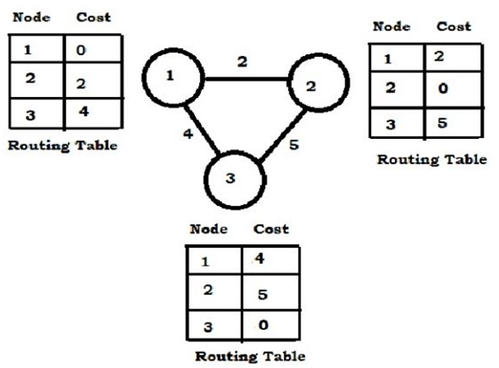

#include<stdio.h>

#include<string.h>

main()

{

int i,j,x,y,n,d,delay=1000;

int edge[50][50],c[50],cost[50][50];

char ch;

printf("\nEnter the No.of nodes in graph: ");

scanf("%d",&n);

for(i=0;i<n;i++)

{

for(j=i;j<n;j++)

{

fflush(stdin);

printf("\nIs there are any edge from %d to %d? ",i+1,j+1);

scanf("%d",&d);

if(d)

{

edge[i][j]=1;

}

else

{

edge[i][j]=0;

}

}

}

printf("\nWhich Routing table do u want to find the cost of which destination? ");

scanf("%d%d",&x,&y);

for(i=0;i<=n;i++)

{

if((edge[i][x-1])==1||(edge[x-1][i])==1)

{

printf("\nEnter the cost of %d node to its neighbour %d:",x,i+1);

scanf("%d",&c[i]);

printf("\nEnter the Routing table entry to %d to %d: ",i+1,y);

scanf("%d",&cost[i][y-1]);

if(delay>(c[i]+cost[i][y-1]))

{

d=i+1;

delay=c[i]+cost[i][y-1];

}

}

}

printf("\nEstimated cost from node %d to %d is %d via the node is %d",x,j,delay,d);

}